Project 4

Using scroll Bars
Make a new directory called Project4 to be used to save the next form and project called scroll.frm and scroll.vbp respectively. Produce a new form so that it looks like the diagram below.
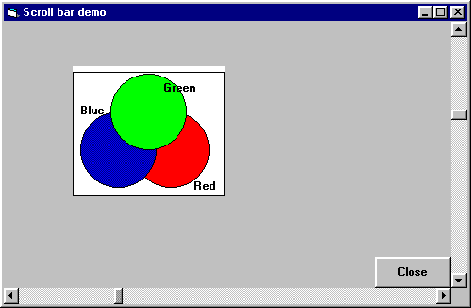
The picture is created within a frame using shape controls. Experiment with the send to Back and Bring Front commands on the Format menu and right click menu when a shape is selected at development time.

Program Design requirements
The code should move the frame with the shapes within the form so that when the vertical scroll bar is at the top the frame is at the top. The maximum and minimum values of the scroll bars should be used to limit the movement of the frame to remain within the boundary of the form.
Code the sub procedure for Change and Scroll events of each scroll bar so that the frame can be moved horizontally and vertically around the screen at run time. HINT the pseudo code for the instruction required for the horizontal scroll bar is as follows. When the scroll bar changes its value, let the Left hand edge of the frame be set to the value of the scroll bar. A similar instruction is required for the vertical scroll bar with the top edge of the frame moving according to the value of the vertical scroll bar. Also when the scroll bars are scrolled allow similar changes to occur.
The design properties for the program so the frame stays in the area of the screen enclosed by the scroll bars; to do this select a suitable value for the following scroll bar properties:
Max | Min
Small Change | Large Change
You will need to experiment with these values in order to see their effects.
Run the program and check that it functions correctly. Debug if necessary.
Produce a printout of your form, form text and code.
Once you have get this program working look at the prepared solution to this problem.

